Data Technician
Week 2 Workbook
Tableau and Power BI

Name: Cisca Human
Course Date: 12/5/2026
Table of contents
Day 2: Task 1 3
Day 2: Task 2 (If completed Day 2 Task 1 Early) 6
Day 3: Task 1 (Optional) 8
Day 3: Task 2 (Optional) 9
Day 4: Task 1 10
Day 4: Task 2 11
Day 4: Task 3 (If completed Task 2 early) 12
Course Notes 13
Additional Resources to learn and Practice 13

Day 3: Task 1 (Optional)
Please complete Tutorial: From Excel workbook to stunning report in Power BI Desktop - Power BI | Microsoft Learn.

Once complete, publish your report in Power BI service and paste a print screen below and in the collaboration board.

You can also watch this video how to publish and share power bi report.webm. and share with your trainer.

“Teaching is the best way to learn, so please listen out for support requests from the class and we’ll work through the challenges together”

Paste your completed lab here

Day 3: Task 2 (Optional)

Please complete Tutorial: Combine data from Excel and an OData feed in Power BI Desktop - Power BI | Microsoft Learn.

Once complete, publish your report in Power BI service and paste a print screen below and share with your trainer.
You can also watch this video how to publish and share power bi report.webm.

Paste your completed lab here | 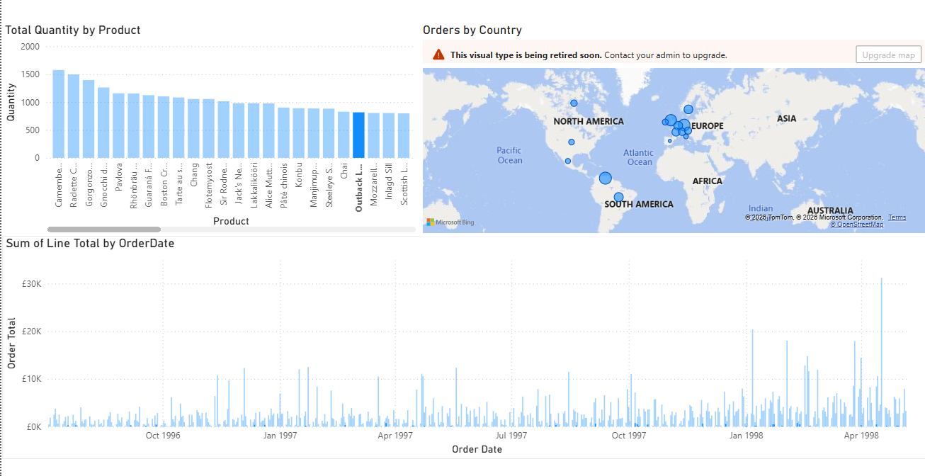

Day 4: Task 1

Please complete Lab 2 ‘Clean, transform, and load data in Power BI’ on Skillable. Once complete, paste a print screen below and in the collaboration board.
- Visit https://leeptalent.learnondemand.net/
- Sing into your profile
- Find PL-300T00-A Design and Manage Analytics Solutions Using Power BI
- Launch and complete Lab 2 ‘Clean, transform, and load data in Power BI’.

“Teaching is the best way to learn, so please listen out for support requests from the class and we’ll work through the challenges together”

Paste your completed lab here | 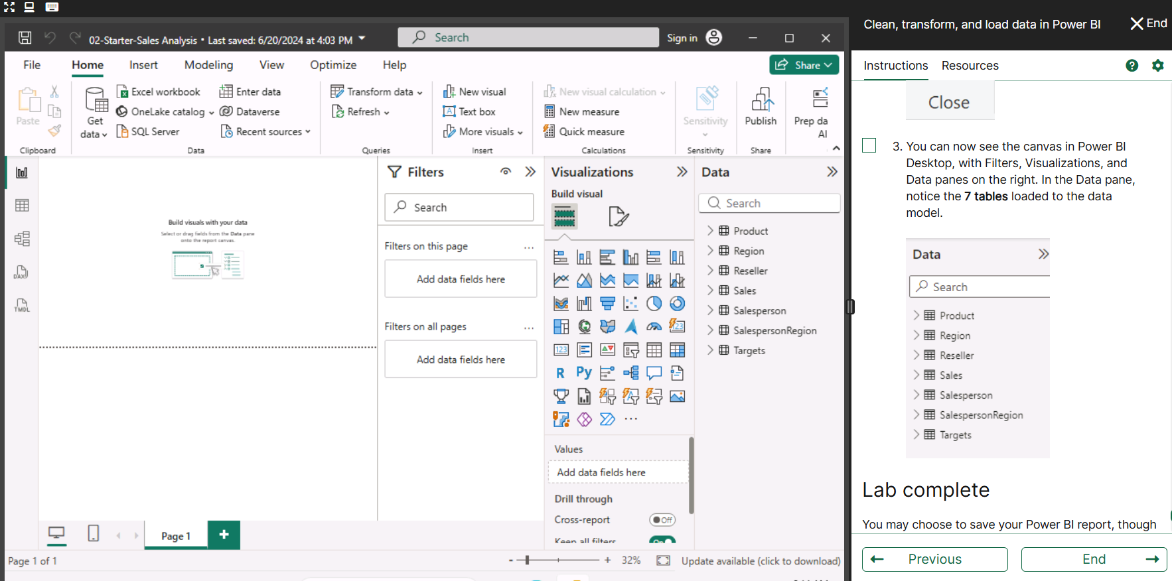

Day 4: Task 2

Please complete Lab 8 ‘Design Power BI reports’ on Skillable. Once complete, paste a print screen below and in the collaboration board.
- Visit https://leeptalent.learnondemand.net/
- Sing into your profile
- Find PL-300T00-A Design and Manage Analytics Solutions Using Power BI
- Launch and complete Lab 8 ‘Design Power BI reports’.

“Teaching is the best way to learn, so please listen out for support requests from the class and we’ll work through the challenges together”

Paste your completed lab here | 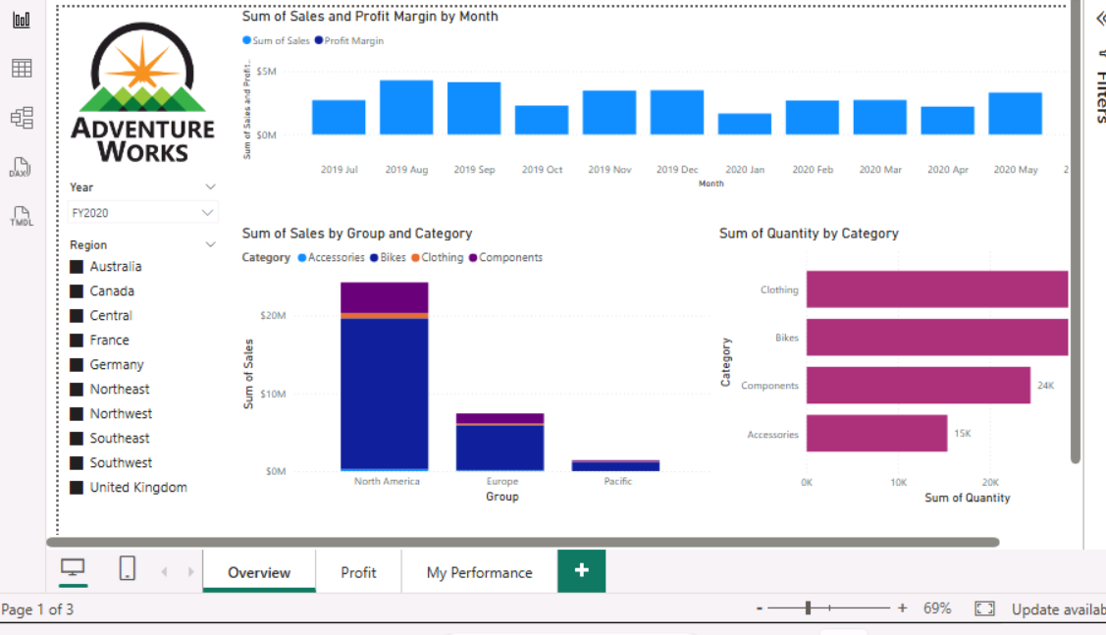  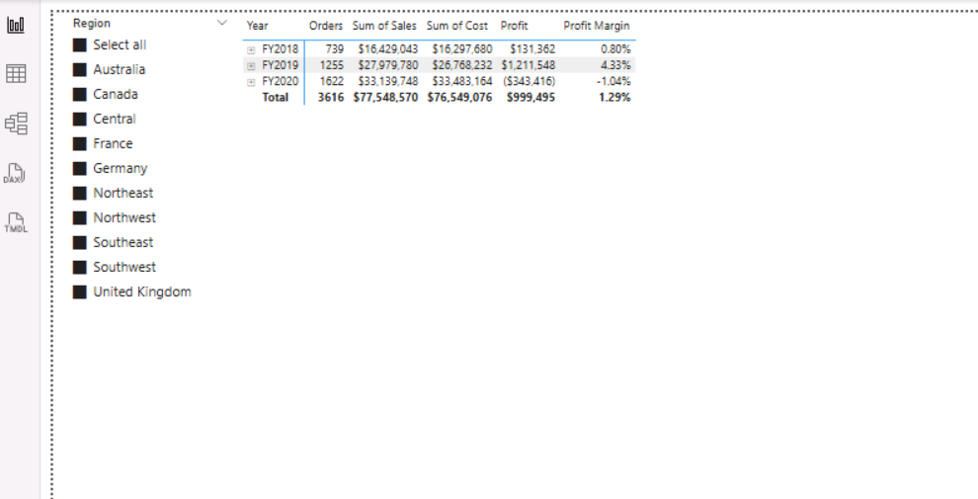  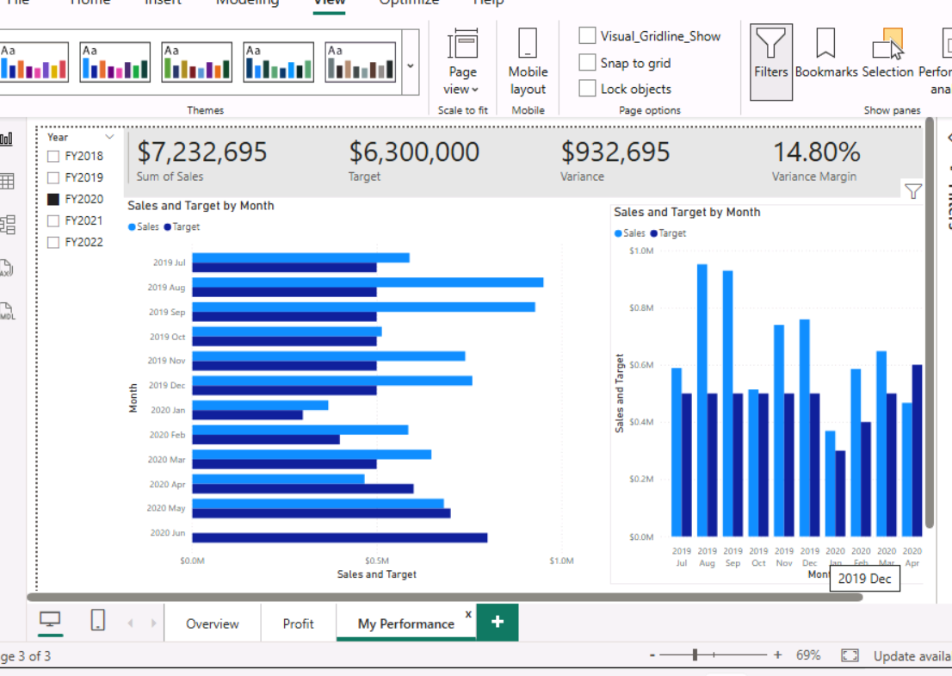

Day 4: Task 3 (If completed Task 2 early)

Please complete Lab 3 ‘Create DAX calculations in semantic models’ on Skillable. Once complete, paste a print screen below and in the collaboration board.
- Visit https://leeptalent.learnondemand.net/
- Sing into your profile
- Find PL-300T00-A Design and Manage Analytics Solutions Using Power BI
- Launch and complete Lab 3 ‘Create DAX calculations in semantic models’.

“Teaching is the best way to learn, so please listen out for support requests from the class and we’ll work through the challenges together”

Paste your completed lab here | Lab 3:  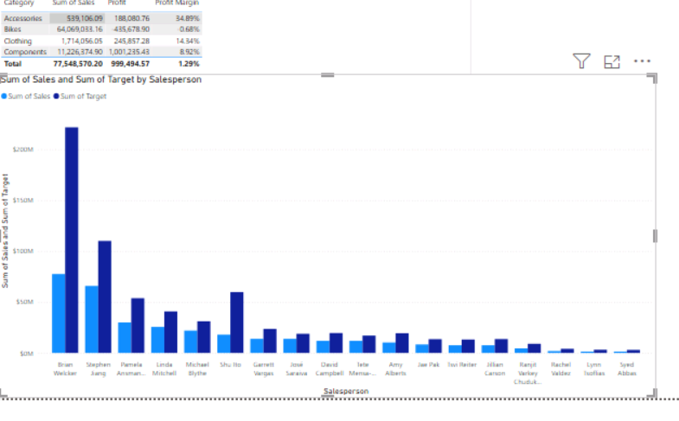  Lab 4:  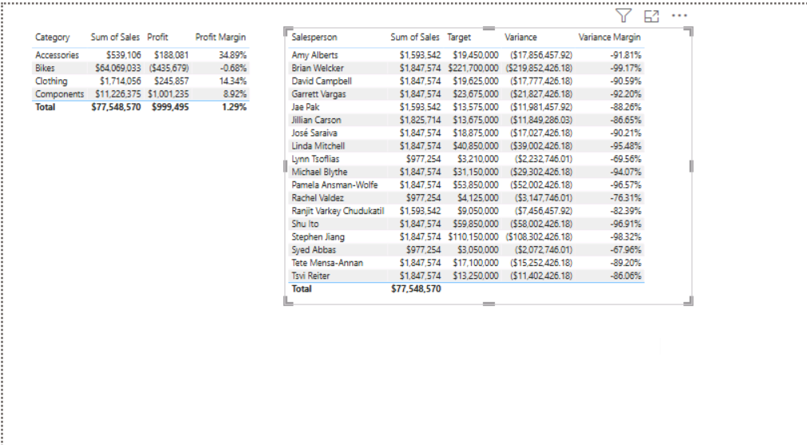  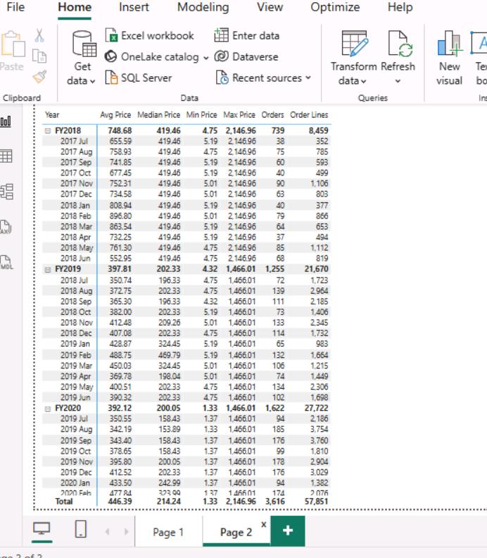

Course Notes

It is recommended to take notes from the course, use the space below to do so, or use the revision guide shared with the class:

Additional Resources to learn and Practice

- Full Beginner Project in Tableau | Tableau Tutorials for Beginners
- Learn Tableau Basic Calculations (Calculated Fields) in Tableau (with 10+ examples) | Part 1
- Tableau Hands-on Challenges Trailmix | Salesforce Trailhead
- Sample Data | Tableau Public
- How-To Videos | Tableau Public
- Power BI Embedded
- Power BI
- Exercise - Configure a semantic model in Power BI Desktop - Training | Microsoft Learn
  - Visit that page
  - Select Sing in to launch Lab
  - Sign in using Leep email
  - Complete puzzle
  - Start Lab
- Power BI Cheat Sheet | DataCamp
- Exercise - Create DAX Calculations in Power BI Desktop - Training | Microsoft Learn.
You can watch the video on how to complete the lab.
How to complete Power BI Labs.webm

- Exercise - Create visual calculations in Power BI Desktop - Training | Microsoft Learn
You can watch the video on how to complete the lab.
How to complete Power BI Labs.webm

END OF WORKBOOK

Please check through your work thoroughly before submitting and update the table of contents if required.

Please send your completed work booklet to your trainer.

